Reduction of Multiple Subsystem

1.

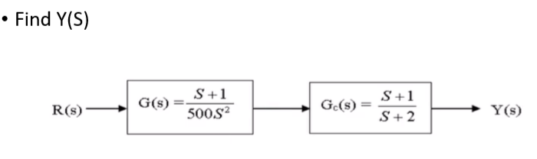

Matlab Code:

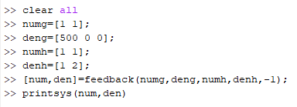

Output:

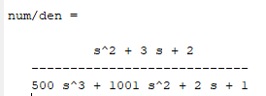

1.1

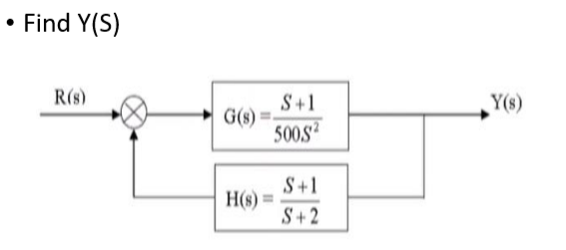

Matlab Code:



Output:



1.3

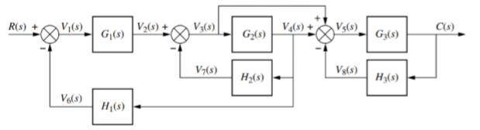

Matlab Code:

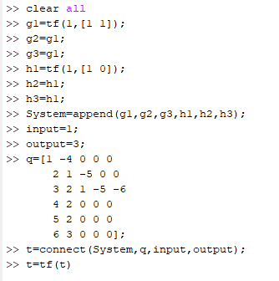

Output:

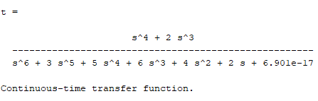

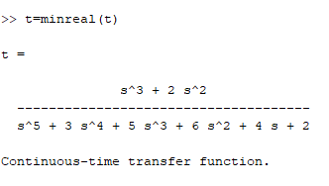

Steady State Error

1.

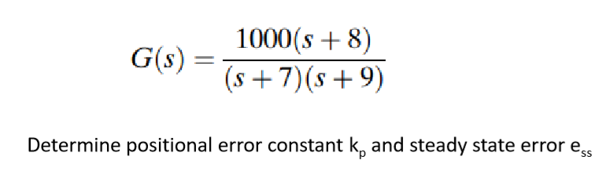

Matlab Code:

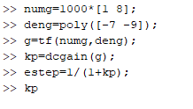

Output:

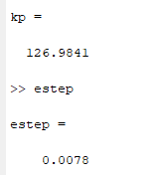

Plot the root locus of the following transfer function using both MATLAB and manually with hand the following transfer function

$G\left(s\right)=\frac{1}{s(s+2)(S^{2}+2s+10)}$

Matlab Code:

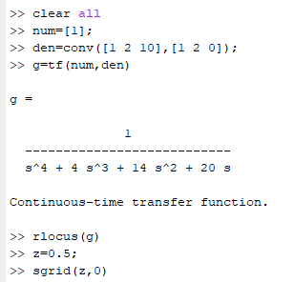

Out Put:

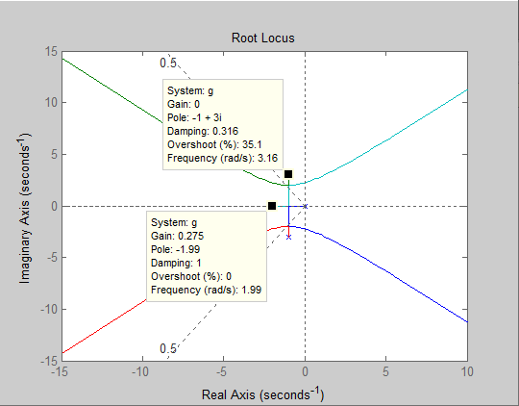

Draw the bode plot of the given transfer functions showing minimum stability margins in the figure.

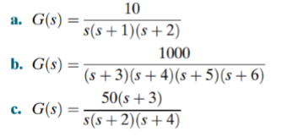

A.Matlab Code:

: 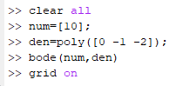

Out put:

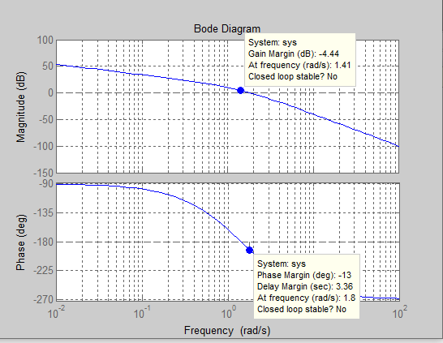

B.Matlab Code:

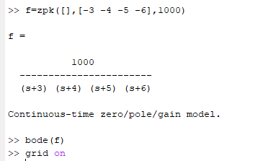

Output:

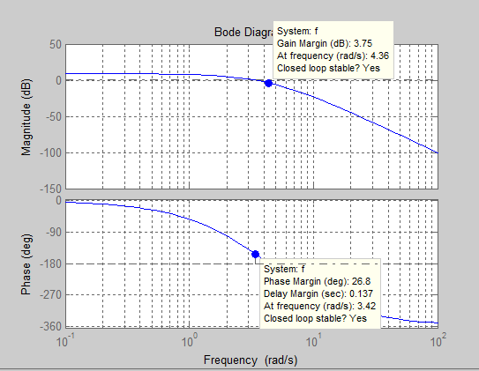

1. Matlab Code:

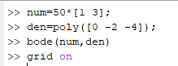

Output:

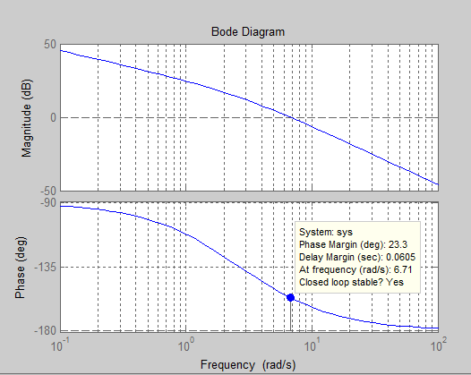

Determine the Gain Margin, Phase Margin, Gain Cross Over Frequency, Phase Cross Over Frequency of any transfer function using both figure and “margin” command.



A . Matlab Code:

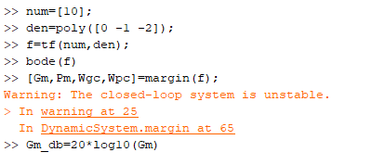

Output:

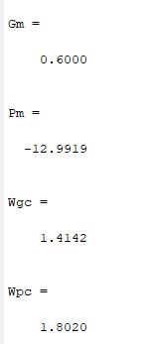

C:\Users\HIFI\Pictures\Communication lab4\3.3o2.PNG

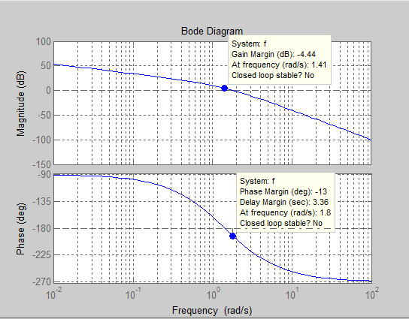

c . Matlab Code:

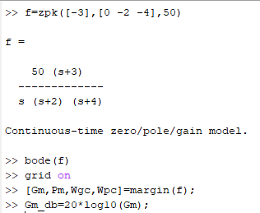

Out put:

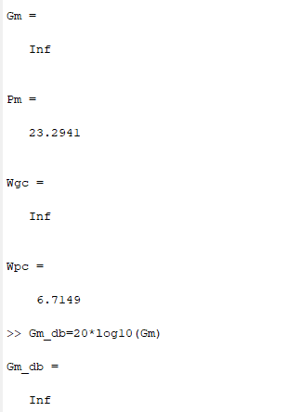

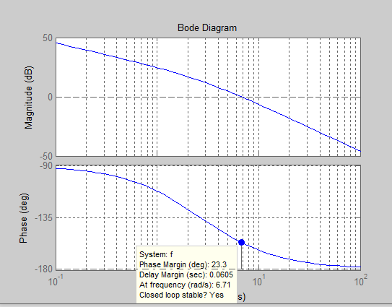

Find the bode plot of the following state models showing minimum stability margins in the figure

A.

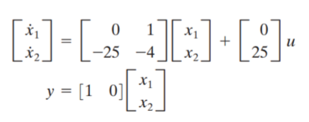

B.

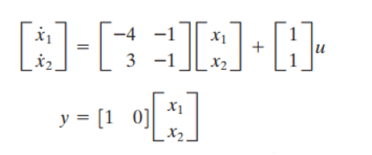

C.

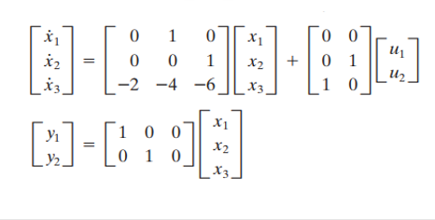

A . Matlab Code:

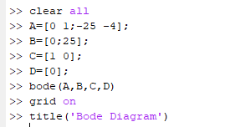

Output:

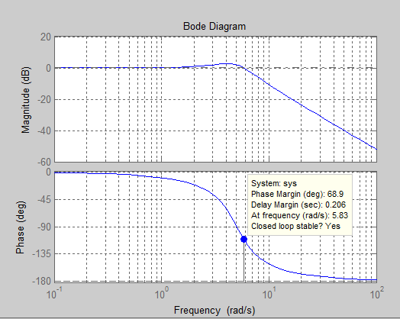

B .Matlab Code:

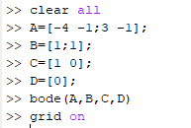

Output:

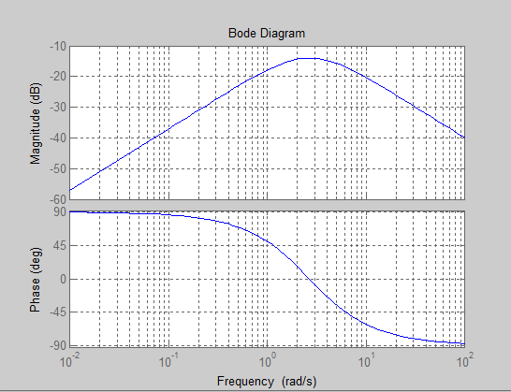

C . Matlab Code:

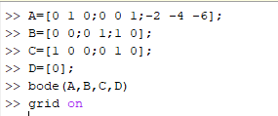

Output:

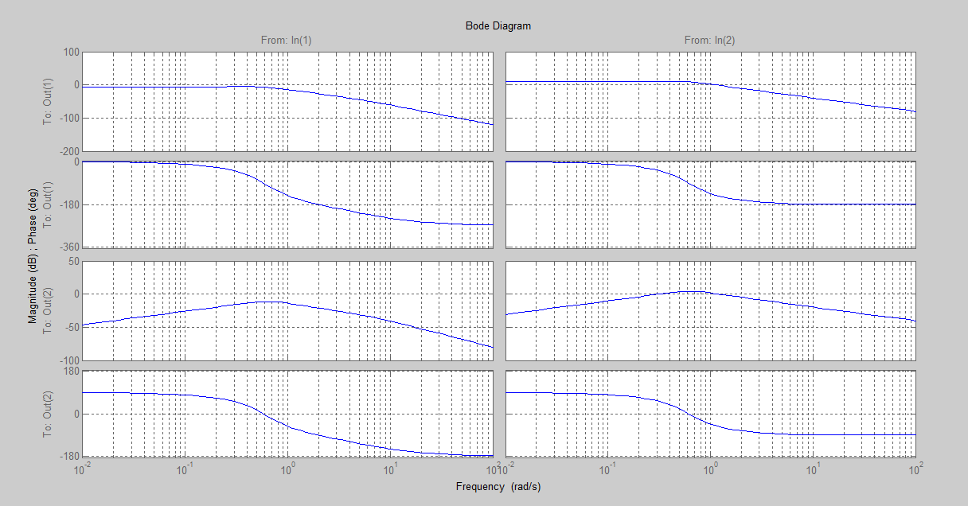

•Show graphically how the change of damping ratio changes the step response for single transfer function of constant natural frequency of 1 rad/sec which is given by

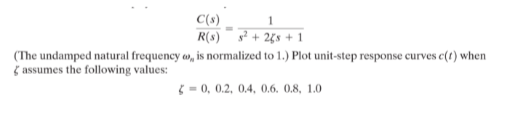

Matlab Code:

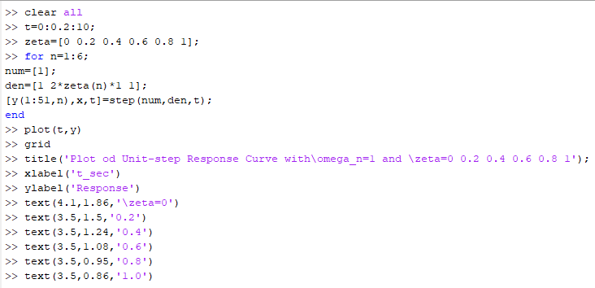

Output:

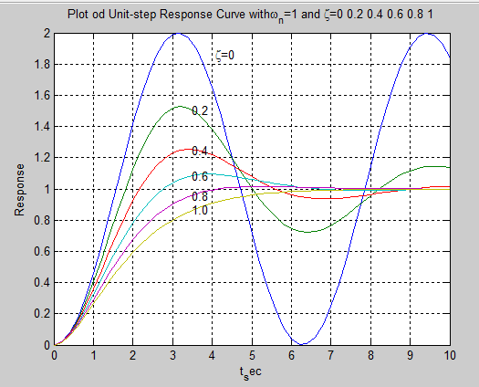

Given the unity feedback system G(S) write a program using MATLAB to determine the value of K for stability.

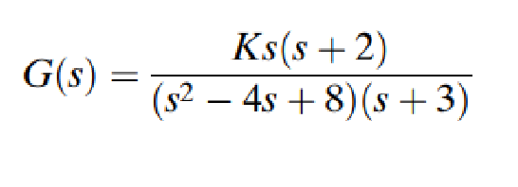

Matlab Code:

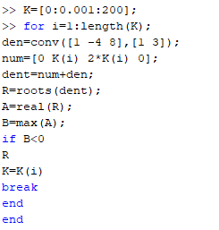

Output:

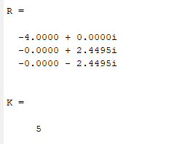

Step Responses of Second order systems according to pole movement

• Prove using MATLAB plot that

1. Frequency of oscillation remains the same for constant imaginary part

2. Envelope remains the same for constant real part

3. Overshoot remains the same for same damping ratio.

Solution: Frequency of oscillation remains the same for constant imaginary part

1 . Matlab code:

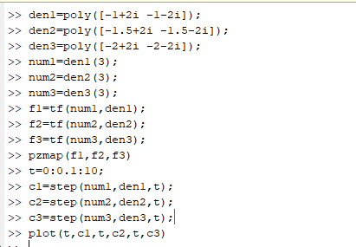

Output

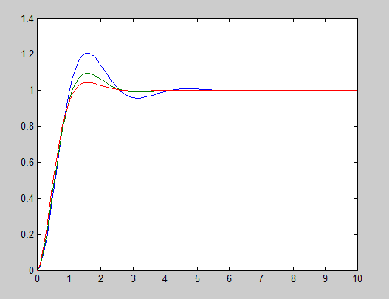

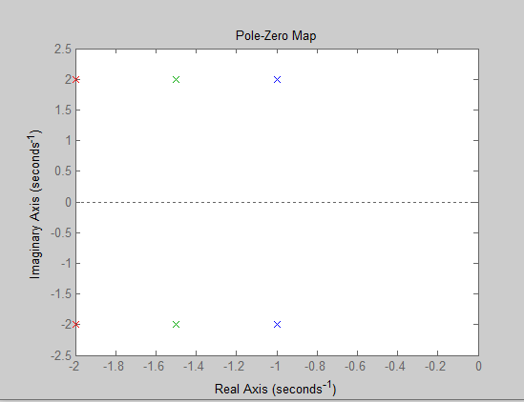

2. Envelope remains the same for constant real part

Matlab Code:

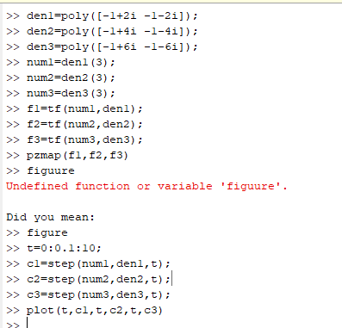

Output:

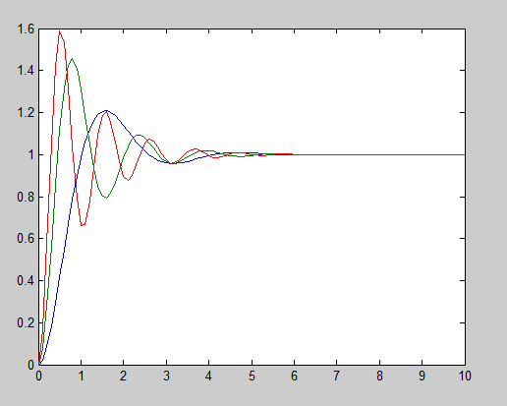

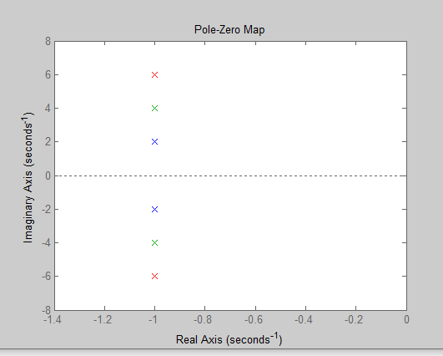

3. Overshoot remains the same for same damping ratio.

Matlab Code:

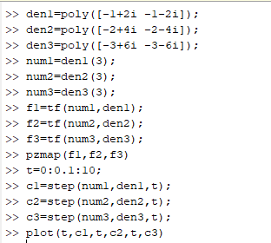

Output:

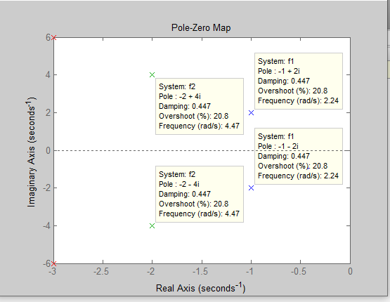

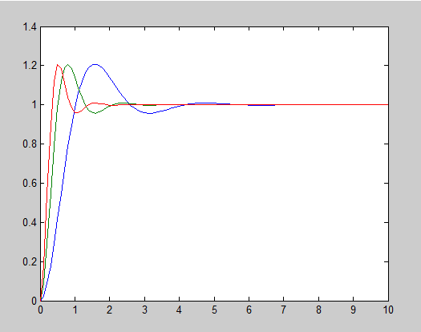

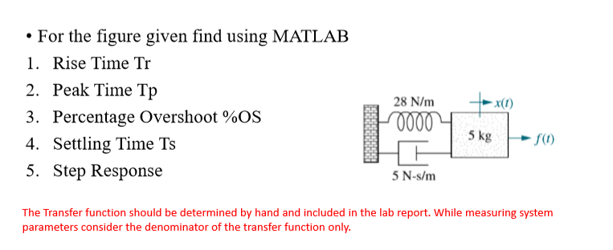

Matlab Code:

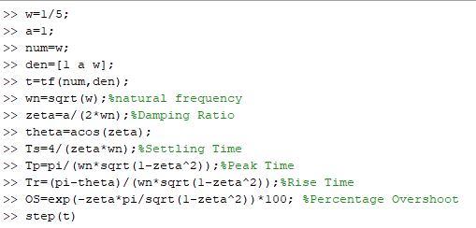

Output:

